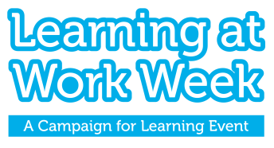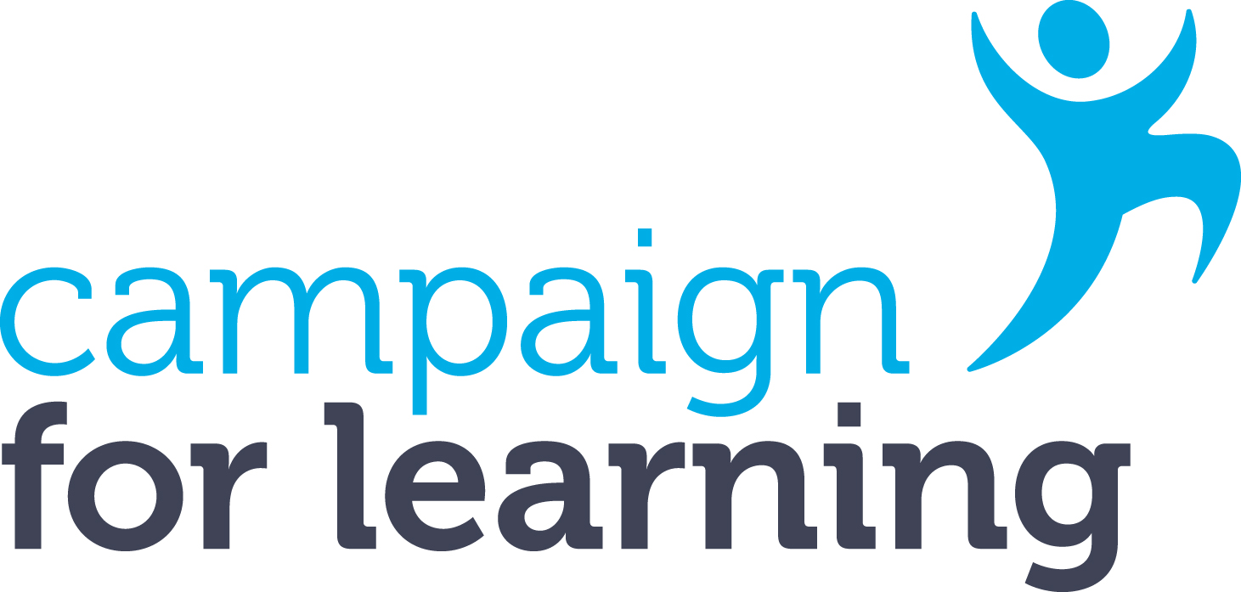
The NCFE and Campaign for Learning
Learning at Work Week Impact Award
'Creating digital futures'

Digital technology has changed and continues to change the way we work, live and learn.
The NCFE and Campaign for Learning Impact Award for Learning at Work Week recognises one large* organisation and one SME** organisation that best demonstrate how their Learning at Work Week activities promoted the use of digital technology to support work, wider life and/or learning.
This may include (but not be limited to) one or more of the following aspects:
- Development of digital skills, including for reskilling and upskilling, and addressing digital exclusion
- Promoting and engaging colleagues in the use of digital tools and apps to support and enhance work, wider life and/or learning
- Raising awareness and understanding of new digital technologies and digital trends and what this means for our future.
Judges will look for evidence of how your company or organisation designed your Learning at Work Week to support the use and understanding of digital technology including your objectives, activities, promotion and evaluation. Judging criteria are included at the end of this form.
The winner will receive a special trophy to recognise their achievement. The award is free to enter and the deadline for submissions is Friday 21st July 2023. Please submit your application along with graphics, photographs or media if available. Non submission of graphics, photos or media is not a disadvantage.
*Large organisations are defined here as having more than 250 employees
**SME organisations are defined here as having no more than 250 employees
About you and your organisation (please note this section is for information only and will not be part of the judging criteria)
Name
Job title
Organisation
Address
Tel
Email
How many employees do you have?
How many employees participated in the event?
Section 1: Objectives
What were your digital objectives for your Learning at Work Week activities and how did they tie into your business objectives and organisational needs? (max 150 words)
Section 2: Partnership work
Did you work in partnership for Learning at Work Week, including internal and external partners? (max 150 words)

How did your partnerships support your digital objectives? (max 150 words)

Section 3: Learning at Work Week activities and supporting your digital objectives
What activities did you offer for Learning at Work Week to support your digital objectives and why? (max 150 words)

How did you design your activities to appeal to your workplace audiences? (max 150 words)

Section 4: Promotion and marketing of your Learning at Work Week activities
How did you promote your Learning at Work Week? (max 150 words)

How did your promotion contribute to achieving your digital objectives? (max 150 words)

Section 5: Evaluation, outcomes and ‘lessons learned’
How were your event and activities monitored and evaluated? (max 150 words)
What were the main outcomes and benefits for employees? What might you do differently next time? (max 150 words)
What were the main outcomes and benefit for the business? What might you do differently next time? (max 150 words)
Declaration
I confirm that all the information given in support of this entry is correct and I understand that information contained in this entry may be used for publicity purposes by the Campaign for Learning in accordance with the Data Protection Act and with, if required, your permission.
Signature
Date
By entering, you give the award sponsors NCFE and Campaign for Learning permission to contact you about products and services which may be of interest. Please tick here if you do NOT wish to receive such messages.

Please submit your entry by email to the Learning at Work Week team at info@cflearning.org.uk
If you do not receive a confirmation of receipt please call: 020 7798 6067
Deadline for submissions: Friday 21st July 2023. Incomplete or late submissions will not be considered.
If you are successful you will be notified by Friday 29th September 2023.
The judges’ decision is final and no correspondence or discussion will be entered into about the results.
JUDGING CRITERIA
To score 25/25 in the scoring system you will need to address all of the following criteria within each of the five sections in addition to telling us about your Learning at Work Week and organisation.
Section 1: Objectives (5 marks)
- Clear rationale behind your Learning at Work Week digital objectives (3 marks)
- How your Learning at Work Week digital objectives linked to your business objectives and organisational needs, e.g., employee needs, practices, programmes and processes (2 marks)

Section 2: Partnership work (3 marks)
- How partnerships contributed to achieving your digital objectives for Learning at Work Week (3 marks)

Section 3: Learning at Work Week activities and supporting your digital objectives (6 marks)

- How you designed and delivered your activities to support your digital objectives (4 marks)
- How you designed your activities to appeal to your workplace audience (2 marks)

Section 4: Promotion and marketing of your Learning at Work Week activities (6 marks)

- How you reached and persuaded your different work audiences to take part in Learning at Work Week (4 marks)
- How your promotion activities supported your digital objectives (2 marks)

Section 5: Evaluation, outcomes and ‘lessons learned’ (5 marks)

- How you monitored and gathered feedback and evidence for evaluation including qualitative and quantitative evidence (3 marks)
- Clear identification and evidence of outcomes for the organisation and employees and what you might do differently next time (‘lessons learned’) (2 marks)

